Research
Introduction
The Northland District Health Board (Northland DHB) recognises the importance of research as a scientific basis to provide more complementary insights towards improving clinical practice. Still, health research plays a pivotal role in improving patient care by developing new treatment methods, theories, and solutions to problems. Since most of the information revolves around personally identifiable health information the researches need to participate in ethical approval and informed consent process to protect patients from undue risk and deprivation of personal rights and dignity
Purpose
All research conducted in Northland DHB must be conducted with the knowledge of Northland DHB and should meet all the requirements of the Health and Disability Ethics Committees (HDECs) from which approval may have been obtained, including all conditions regarding informed consent.
Statement
A systematic investigation designed to develop or contribute to knowledge. Research may include the evaluation of clinical practice to determine its safety and efficacy.

All health and disability research must comply with established ethical standards. The HDECs check that proposed health and disability research meets or exceeds established ethical standards determined by the National Ethics Advisory Committee (NEAC). These ethical standards are contained in:
- Ethical Guidelines for Observational Studies
- Ethical Guidelines for Intervention Studies.

These standards apply to all health and disability research, regardless of whether HDEC review is required for that research.

Not all health and disability research requires HDEC review. The complete definition of the scope of HDEC review is contained at section 3 of the SOPs for HDECs. View the summary flowchart on page 3.

A study is likely to require HDEC review if it involves:
- Human participants recruited in their capacity as:
  - Consumers of health or disability support services; or
  - Relatives or caregivers of such consumers; or
  - Volunteers in clinical trials; or
- Human tissue; or
- Health information

Appendix B

Process
- Whether a research proposal requires HDEC approval or not, a locality assessment must be undertaken to review all research conducted at Northland DHB. Locality assessments will consider resource implications, suitability of the local researcher and research environment, and cultural issues – see process.

- Researchers should complete Section 1 of the Locality Assessment Summary form, and email this back to the chief medical officer with the research proposal and any other relevant information (participant and other consents, information sheets, questionnaires, approvals, etc.)

- The Chief Medical Officer (CMO) may meet with the researcher to discuss (or discuss via email) the proposal prior to sign off on the locality assessment form.

- When the locality assessment has been approved, the CMO will forward a signed copy of the Locality Assessment Summary form to the researcher. The CMO will also provide electronic authorisation via NZ Online forms if that is required; email address for online forms is Michael.roberts@northlanddhb.org.nz

- The Maori Health Directorate will be advised of all research proposals and will contact the researcher for any additional information they require, prior to their formal review and sign off.

- No research project can be undertaken until it has received locality assessment approval from both the CMO and the Maori Health Directorate. The research should be performed according to the proposal approved by the Locality Assessment. The researchers must adhere at all times to the proposal’s stipulations regarding consent procedures, cultural sensitivity and provision of information to participants.

5. The CMO will keep a database of all research activities at Northland DHB and the researcher should provide a report to the CMO outlining the outcome of the research.
References
- Code of Health & Disability Services Consumers' Rights 1996, Right 6 & 9
- Health & Disability Ethics Committees
Appendices
Appendix A – Does your study require HDEC review?
Appendix B – Locality Assessment Approval Process for research at Northland DHB
Appendix C – Locality Assessment Form

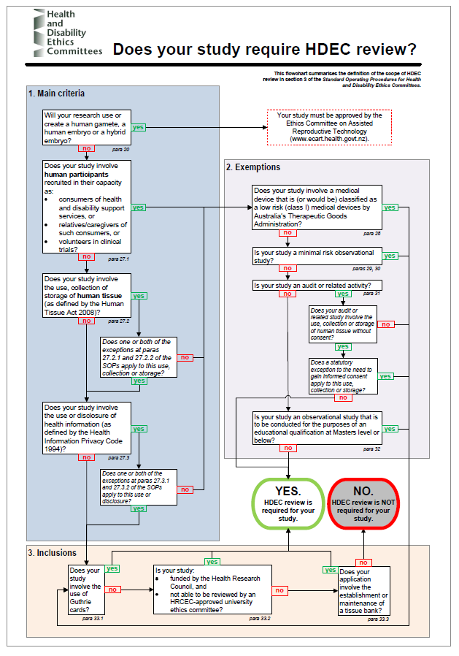
Appendix A
Appendix A – Does your study require HDEC review?

Appendix B

Locality Assessment Approval Process for Research at Northland DHB
Locality Assessment No. 2021-
Appendix C – Locality Assessment Form

Locality Assessment Sign Off
All research conducted in the Northland DHB must be conducted with the knowledge of the Northland DHB, and must meet all the requirements of the Health & Disability Ethics Committees (HDECs), though not all research will require HDEC review.

A locality assessment must be undertaken to review all research conducted at Northland District Health Board. Locality Assessments will consider resource implications, suitability of the local researcher and research environment, and cultural issues.

Part One: General
Full project title:
Short project title:
Locality to be assessed: | Northland
Brief outline of study:
Research timeframe:
Researcher:
Researcher contact details:
Other researchers/investigators:
Their contact details:

Part Two: Locality Issues
Identify any local issues and specify how these issues will be addressed.
- Suitability of local researcher ☐ Yes ☐ No
For example, are all roles for the investigator(s) at the local site appropriate
(ie, has any conflict the investigator might have between her or his local roles in research and in patient care been adequately resolved)?
- Suitability of the local research environment
      - Are all the resources (other than funding that is conditional on ethical ☐ Yes ☐ No
approval) and/or facilities that the study requires appropriate and available (for example, is staffing adequate? Is this site accessible for mobility-impaired people where necessary)?
      - Have all potentially affected managers of resources such as clinical records or ☐ Yes ☐ No
laboratory managers been notified?
- Have issues such as cultural issues specific to this locality or to people being ☐ Yes ☐ No
recruited at this locality been addressed?
- Have the local investigator contact details and other important contact details been ☐ Yes ☐ No
provided to the locality organisation for checking?
- Has the local investigator been advised of the unacceptability of using personal ☐ Yes ☐ No
hand-held devices to photograph identifiable patient information?

Part Three: Declaration by locality organisation
I am authorised to complete locality approval on behalf of this locality organisation. I understand that I may withdraw locality approval if any significant local concerns arise. I agree to advise the principal investigator and then the relevant ethics committee should this occur.

I confirm the organisation has sufficient indemnity insurance to compensate participants for harm that does not qualify for compensation under the Injury Prevention, Rehabilitation and Compensation Act 2001.

Signature: |  | Date:
Name: | Dr Michael Roberts | Position: | Chief Medical Officer
Contact details: | Northland District Health Board, Private Bag 9742, Whangarei 0148

